Adding Guest Page Volumes

|  |  |  |  |  |  |  |  |  |  |  |  |  |  |
| --- | --- | --- | --- | --- | --- | --- | --- | --- | --- | --- | --- | --- | --- |
| |  | | --- | | Document Legend |   C:\Users\P00341017\Documents\JA FileZ\Key Information\Misc Office\Jordan's Document Command Legend.png   * O The Structure / Syntax line displays the structure of the command and labels the parts. * O Example Command lines are verbatim or previously used command inputs that can actually be used or copied. * O Input / Output lines contain real images of the command in use, often showing context. * Purple highlights denote commands. * Red highlights denote user supplied or contextually dictated values. * Blue highlights denote options or operands that change how commands function. * Some commonly used abbreviations:  |  |  |  |  |  |  | | --- | --- | --- | --- | --- | --- | | Fn | Ft | Fm | Vdev | Mdisk | Mode | | Filename | Filetype | Filemode | Virtual Device Address | Minidisk | Disk Label, Read/write permissions | |

1. Identify available DASD, pay attention to their location and proximity to the system. Be sure to separate them from other types of volumes that may have growth and need more DASD in time. Once you’ve selected suitable devices mark down the current device address and volser (if it has one.)
   1. Attach vdev  
      att 2d17-2d1a *  
      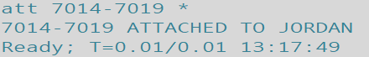
2. Format the DASD for CP usage.
   1. Cpvol operand unit(vdev) option volid(volser)  
      cpvol format unit(2d17) noverify volid(st1p02)  
      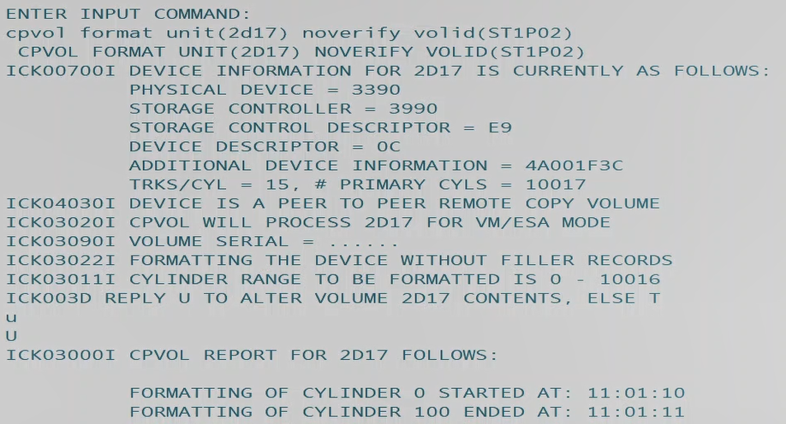
   2. Type, “U” to confirm.  
      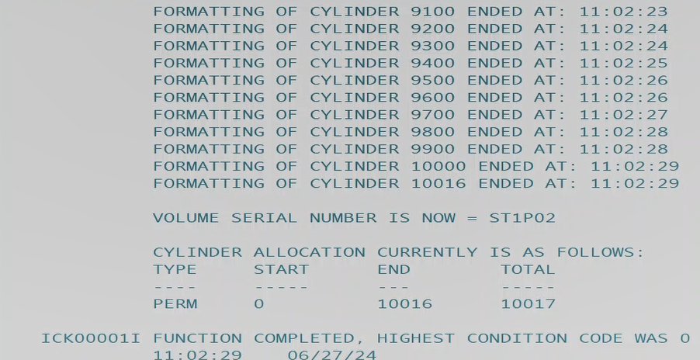
3. Allocate cylinders, cylinder 0 will be TYPE perm (0,0) and cylinders 1 to 10,016 will be TYPE Page.
   1. Cpvol operand unit(vdev) verify(volser) type((page,StartCylinder#,EndCylinder#))  
      cpvol allocate unit(2d1a) verify(ST1P05) type((page,1,10016))  
      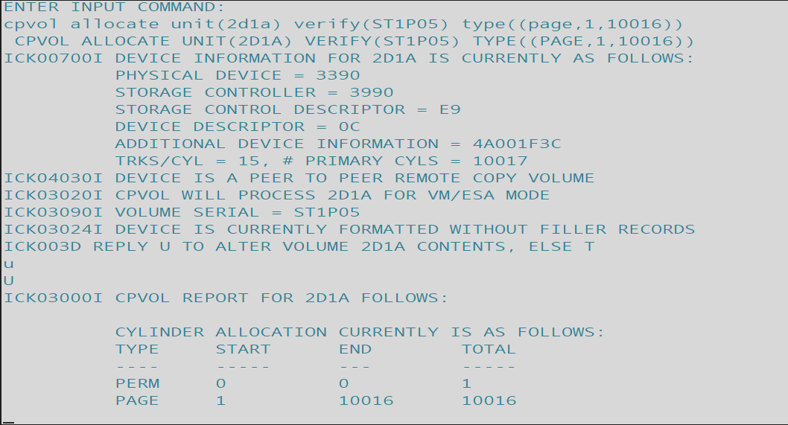
      1. Optionally the two types may be input on the same line:  
         cpvol allocate unit(2d09) noverify type((perm,0,0),(page,1,10016))  
         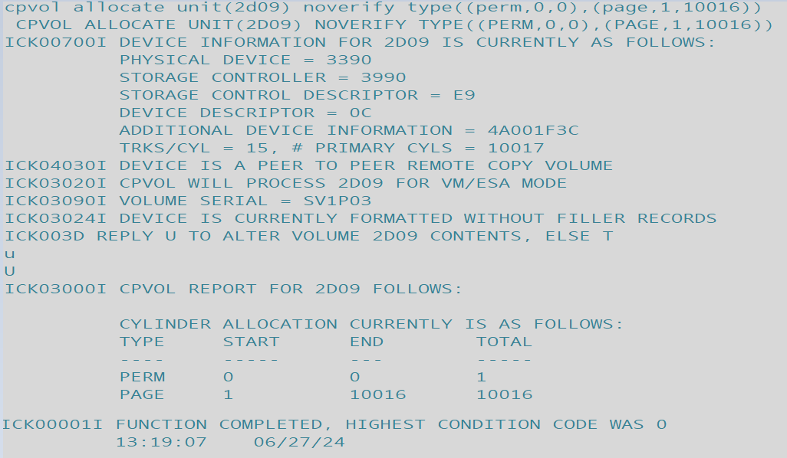
   2. Type, “U” to confirm and initiate the change.
   3. Cpvol operand unit(vdev) verify(ST1P05) type((type,cylinder#,cylinder#))  
      cpvol allocate unit(2d17) noverify type((perm,0,0))  
      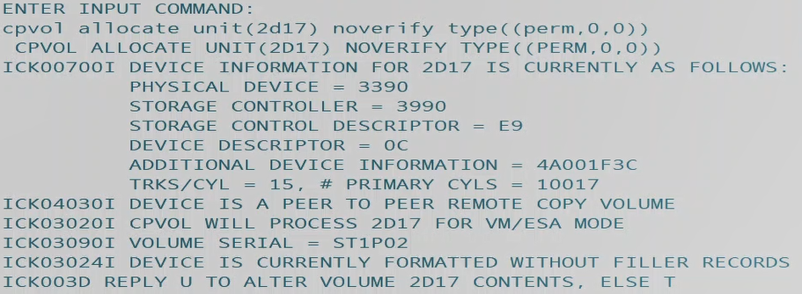
   4. Type, “U” to confirm and apply changes.  
      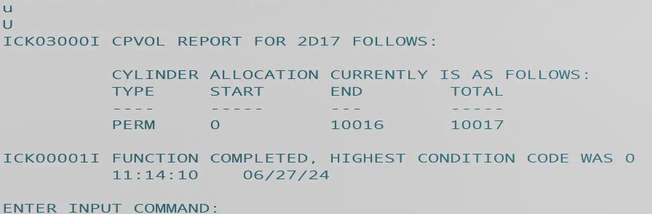
4. Verify new values with CPVOL List.
   1. CPVOL LIST Unit(vdev) options  
      cpvol list unit(2d17) noverify  
      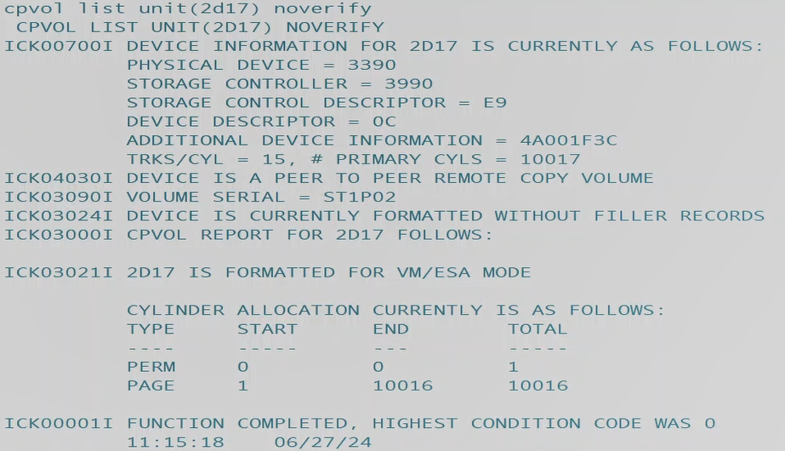
5. Establish ownership with CPVOL Owner command, establishing this system and cluster as the owners of this volume and apply the changes by typing, “U” when prompted.
   1. CPVOL operand unit(vdev) vfy(volid) ssiname(xxxxxxx) sysname(xxxxxxx)  
      cpvol owner unit(2d17) vfy(ST1P02) ssiname(st1clust) sysname(st1res)  
      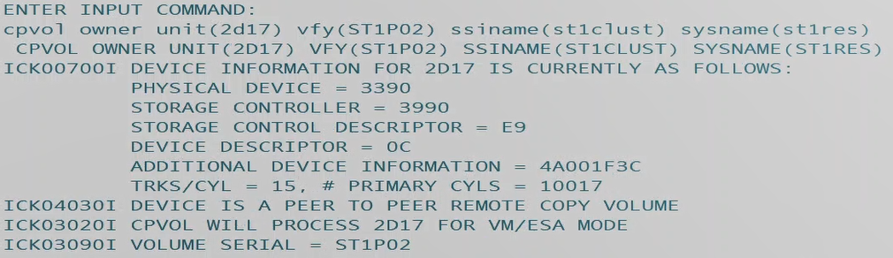
   2. U  
      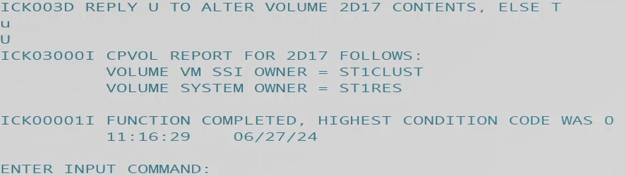
   3. End  
      end  
      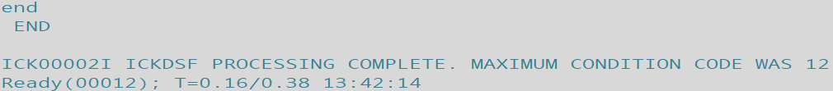
6. Establish that the volume is CP-Owned with the CP Owned Slot# command.
   1. Define operand slot slot# volid  
      define cpowned slot 254 st1p02  
      
7. Establish permanence for the newly CP-Owned page volume slot within System Config’s page volume list by adding statements. First gain access to PMAINT Cf0, where Sys Config resides, navigate to the Page Volume list and write in the statement. It is a good practice to make a backup copy of System Config when performing changes like these.
   1. VMLINK user mdisk (options  
      vmlink pmaint cf0 (write  
      
   2. Filelist fn ft fm  
      filel * * x  
      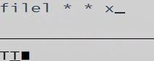
   3. Copyfile fn ft fm newfn newft newfm (options  
      copyfile system config x = confwk x (olddate  
      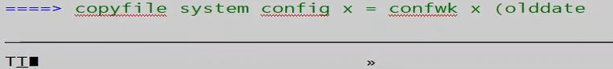
   4. X  
      X  
      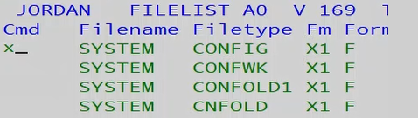
   5. /Searchterm  
      /Page  
      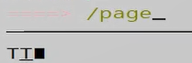
   6. “#  
      “  
      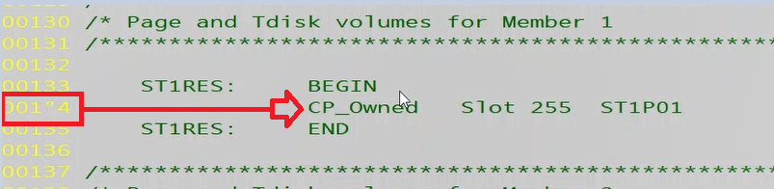
      1. Edit the lines to new values matching new DASD. The first standard slot begins at the **end** as there are 255 slots total, the next added volume would be Slot 254 for ST1P02.  
         
   7. File  
      File  
      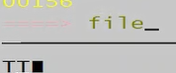
8. Detach the devices from yourself, vary them off and then back online to refresh the system and your user view of them as resources.
   1. Detach vdev  
      det 2d17-2d1a *  
      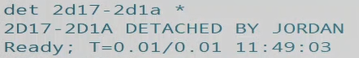
   2. Vary offline vdev  
      vary offline 2d17-2d1a  
      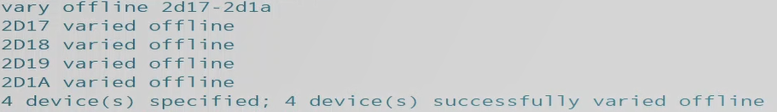
   3. Vary online vdev  
      vary online 2d17-2d1a  
      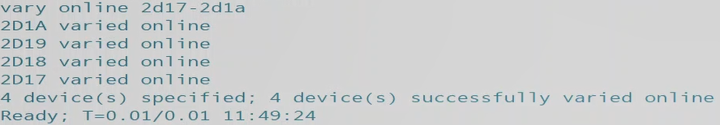
9. Attach the DASD to system.
   1. Attach vdev to name  
      att 2d08-2d09 to system  
      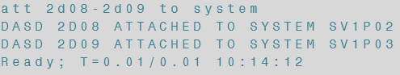
10. Utilize Vir2real exec, Query DASD and Allocation to confirm the DASD now show up properly with the correct values.
    1. Query operand type  
       q alloc page  
       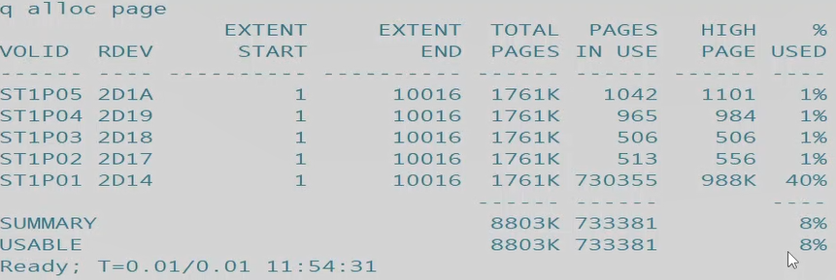
    2. VIR2REAL  
       vir2real  
       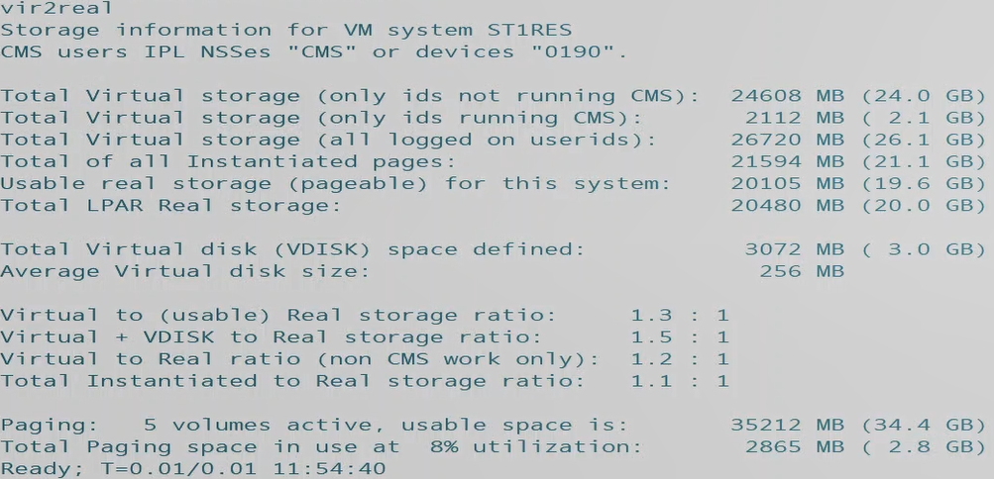
    3. Query operand option  
       q dasd  
       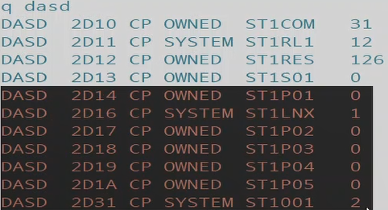
11. Finished!